**Phase 5**

**Lesson 3**

**Delete an S3 Bucket**

Steps:

1. Selecting the S3 bucket you want to delete

2. Deleting the bucket

Step 1: Selecting the S3 bucket you want to delete

Choose the bucket

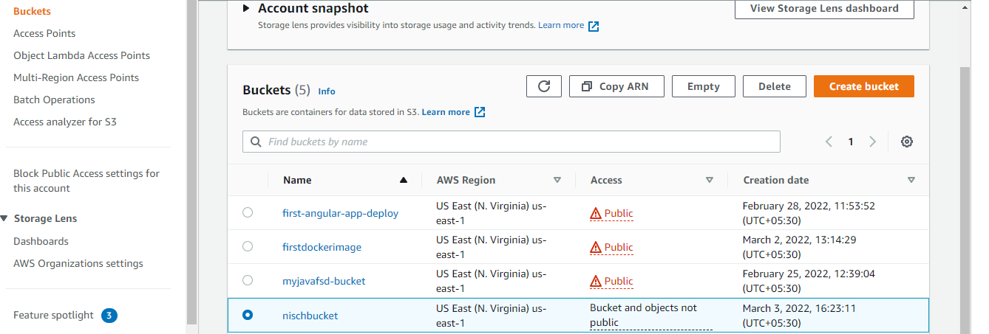

Step 2: Deleting the bucket

